
Git & GitHub
Objective: Practise the full Git workflow — SSH setup, branching, merging, conflict resolution, sequential commits, git reset, and rebasing — using a Flask project.

Task 1: Repository Setup & First Branch
- Create a new GitHub repository. Done (https://github.com/Lukky175/TuteDude_Git-GitHub.git)

- Clone the repository to your local machine using SSH (generate an SSH key if needed, and add the public key to your GitHub account).

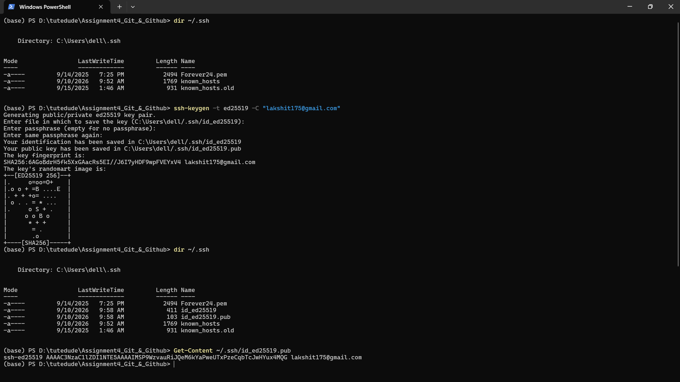

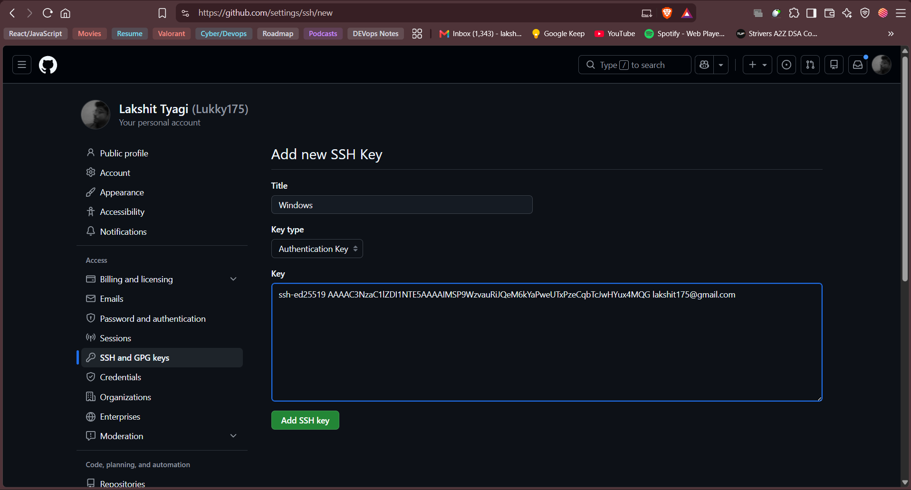

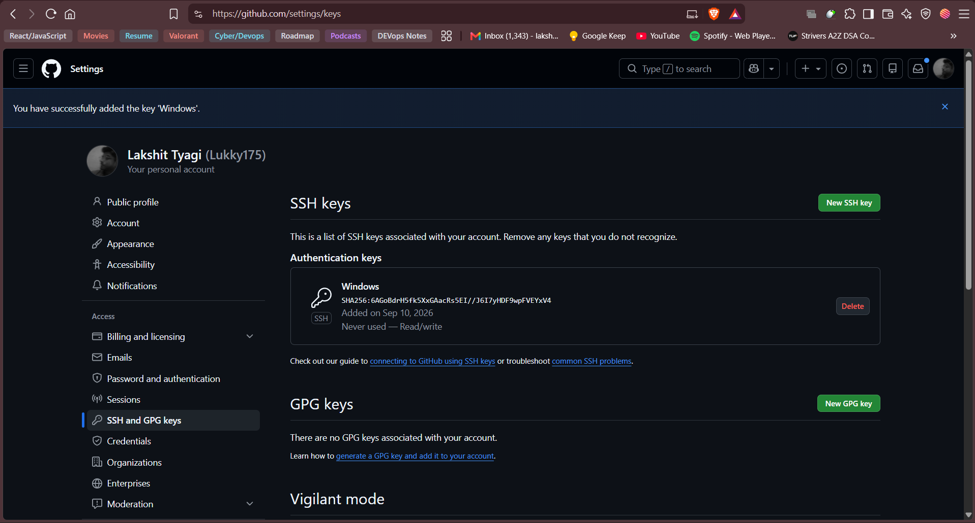

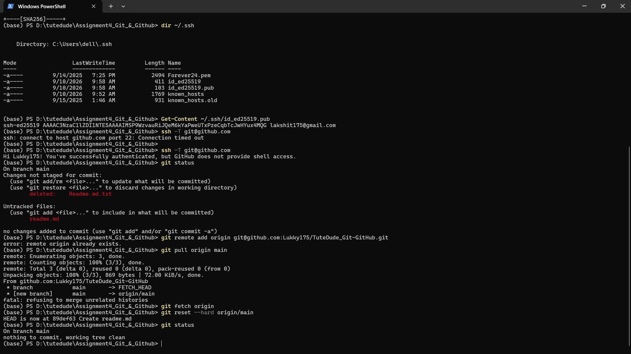

- Create a new branch named after your username (e.g., Tutedude).

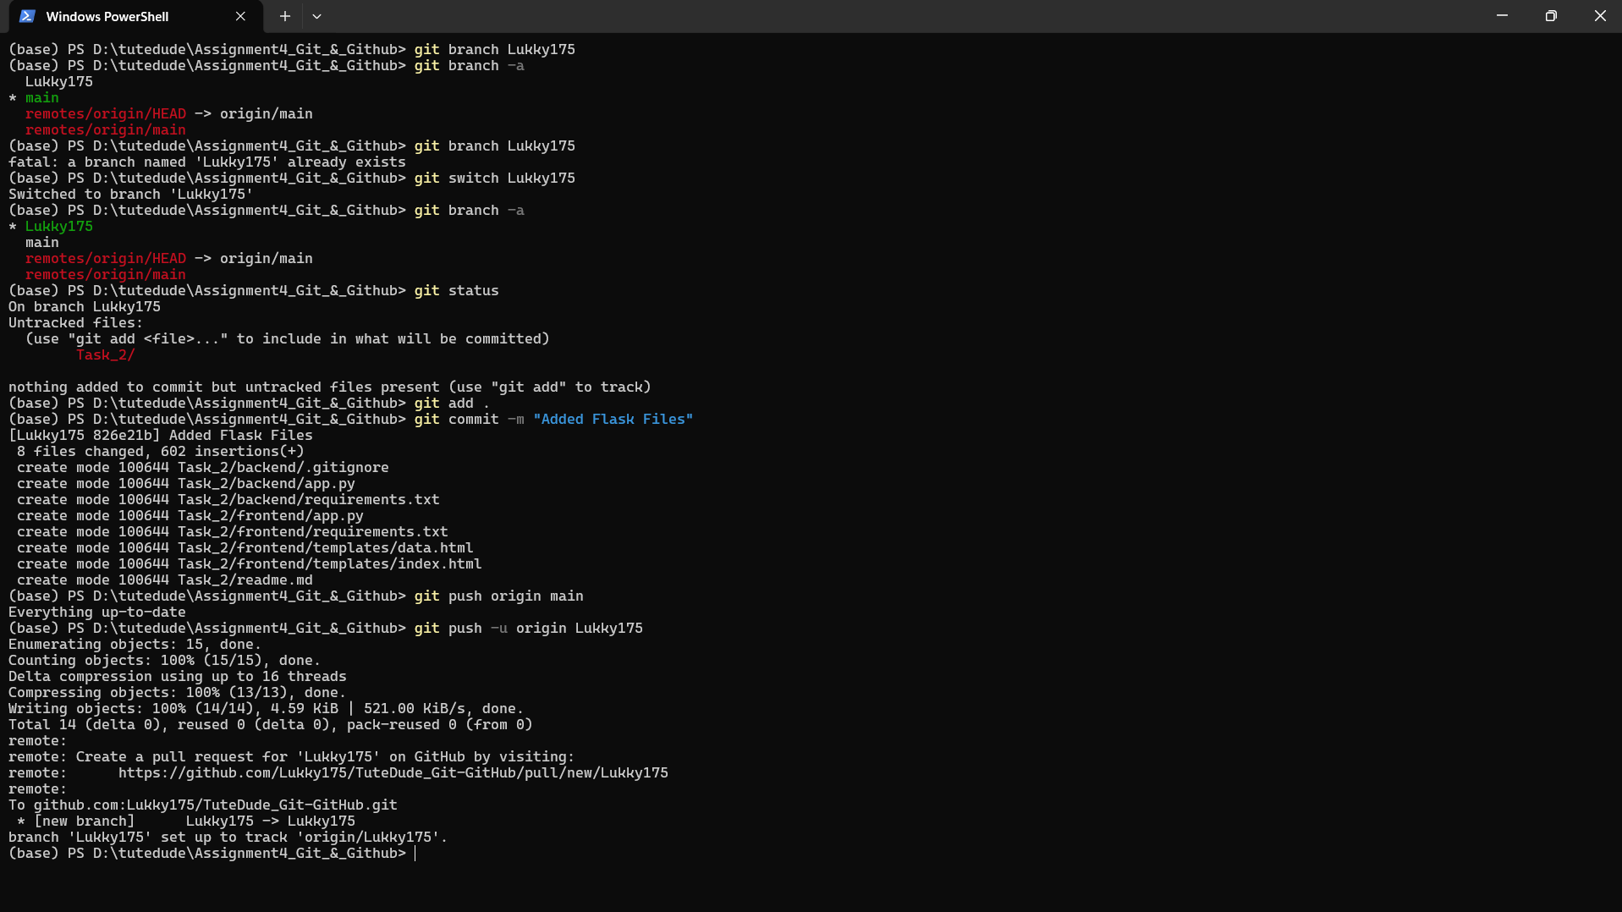
(base) PS D:\tutedude\Assignment4_Git_&_Github> git branch Lukky175
(base) PS D:\tutedude\Assignment4_Git_&_Github> git branch -a
Lukky175
* main
remotes/origin/HEAD -> origin/main
remotes/origin/main
(base) PS D:\tutedude\Assignment4_Git_&_Github> git branch Lukky175
fatal: a branch named 'Lukky175' already exists

- Add your Flask project files to this branch.

(base) PS D:\tutedude\Assignment4_Git_&_Github> git switch Lukky175
Switched to branch 'Lukky175'
(base) PS D:\tutedude\Assignment4_Git_&_Github> git branch -a
* Lukky175
main
remotes/origin/HEAD -> origin/main
remotes/origin/main
(base) PS D:\tutedude\Assignment4_Git_&_Github> git status
On branch Lukky175
Untracked files:
(use "git add <file>..." to include in what will be committed)
Task_2/

nothing added to commit but untracked files present (use "git add" to track)
(base) PS D:\tutedude\Assignment4_Git_&_Github> git add .
(base) PS D:\tutedude\Assignment4_Git_&_Github> git commit -m "Added Flask Files"
[Lukky175 826e21b] Added Flask Files
8 files changed, 602 insertions(+)
create mode 100644 Task_2/backend/.gitignore
create mode 100644 Task_2/backend/app.py
create mode 100644 Task_2/backend/requirements.txt
create mode 100644 Task_2/frontend/app.py
create mode 100644 Task_2/frontend/requirements.txt
create mode 100644 Task_2/frontend/templates/data.html
create mode 100644 Task_2/frontend/templates/index.html
create mode 100644 Task_2/readme.md
(base) PS D:\tutedude\Assignment4_Git_&_Github> git push origin main
Everything up-to-date
(base) PS D:\tutedude\Assignment4_Git_&_Github> git push -u origin Lukky175
Enumerating objects: 15, done.
Counting objects: 100% (15/15), done.
Delta compression using up to 16 threads
Compressing objects: 100% (13/13), done.
Writing objects: 100% (14/14), 4.59 KiB | 521.00 KiB/s, done.
Total 14 (delta 0), reused 0 (delta 0), pack-reused 0 (from 0)
remote:
remote: Create a pull request for 'Lukky175' on GitHub by visiting:
remote: https://github.com/Lukky175/TuteDude_Git-GitHub/pull/new/Lukky175
remote:
To github.com:Lukky175/TuteDude_Git-GitHub.git
* [new branch] Lukky175 -> Lukky175
branch 'Lukky175' set up to track 'origin/Lukky175'.
(base) PS D:\tutedude\Assignment4_Git_&_Github>

- Commit the changes and merge the branch into the main branch.
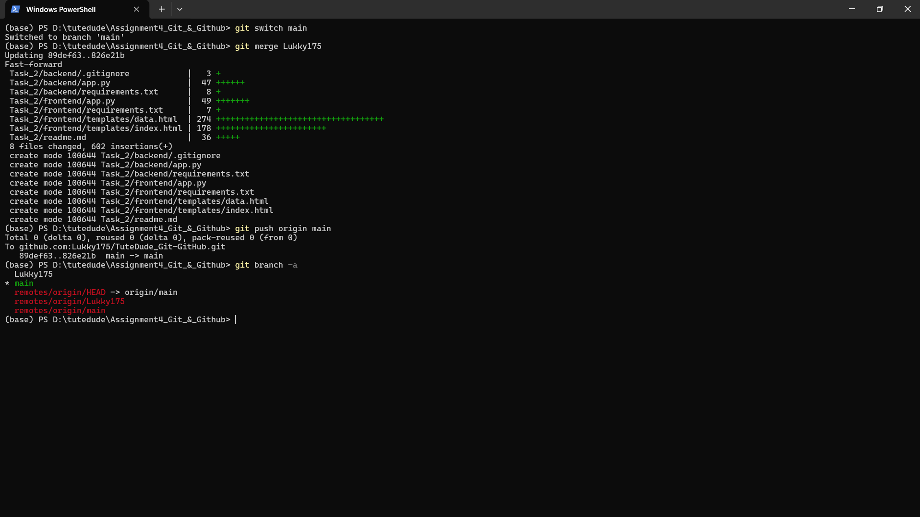

(base) PS D:\tutedude\Assignment4_Git_&_Github> git switch main
Switched to branch 'main'
(base) PS D:\tutedude\Assignment4_Git_&_Github> git merge Lukky175
Updating 89def63..826e21b
Fast-forward
Task_2/backend/.gitignore | 3 +
Task_2/backend/app.py | 47 ++++++
Task_2/backend/requirements.txt | 8 +
Task_2/frontend/app.py | 49 +++++++
Task_2/frontend/requirements.txt | 7 +
Task_2/frontend/templates/data.html | 274 +++++++++++++++++++++++++++++++++++
Task_2/frontend/templates/index.html | 178 +++++++++++++++++++++++
Task_2/readme.md | 36 +++++
8 files changed, 602 insertions(+)
create mode 100644 Task_2/backend/.gitignore
create mode 100644 Task_2/backend/app.py
create mode 100644 Task_2/backend/requirements.txt
create mode 100644 Task_2/frontend/app.py
create mode 100644 Task_2/frontend/requirements.txt
create mode 100644 Task_2/frontend/templates/data.html
create mode 100644 Task_2/frontend/templates/index.html
create mode 100644 Task_2/readme.md
(base) PS D:\tutedude\Assignment4_Git_&_Github> git push origin main
Total 0 (delta 0), reused 0 (delta 0), pack-reused 0 (from 0)
To github.com:Lukky175/TuteDude_Git-GitHub.git
89def63..826e21b main -> main
(base) PS D:\tutedude\Assignment4_Git_&_Github> git branch -a
Lukky175
* main
remotes/origin/HEAD -> origin/main
remotes/origin/Lukky175
remotes/origin/main
(base) PS D:\tutedude\Assignment4_Git_&_Github>

Task 2: Update JSON & Resolve Conflicts
- Create a new branch named _new (e.g., Tutedude_new).
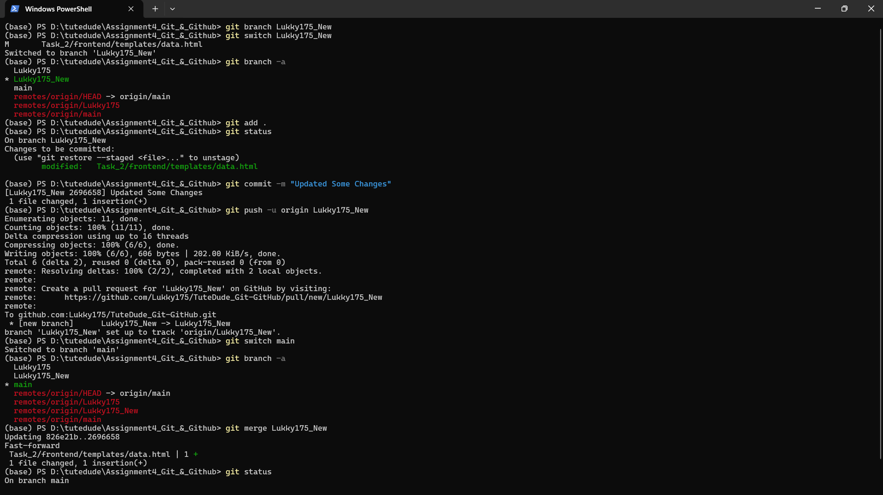
(base) PS D:\tutedude\Assignment4_Git_&_Github> git branch Lukky175_New
(base) PS D:\tutedude\Assignment4_Git_&_Github> git switch Lukky175_New
M Task_2/frontend/templates/data.html
Switched to branch 'Lukky175_New'
(base) PS D:\tutedude\Assignment4_Git_&_Github> git branch -a
Lukky175
* Lukky175_New
main
remotes/origin/HEAD -> origin/main
remotes/origin/Lukky175
remotes/origin/main

- Update the content of the JSON file used for the /api route in this branch.
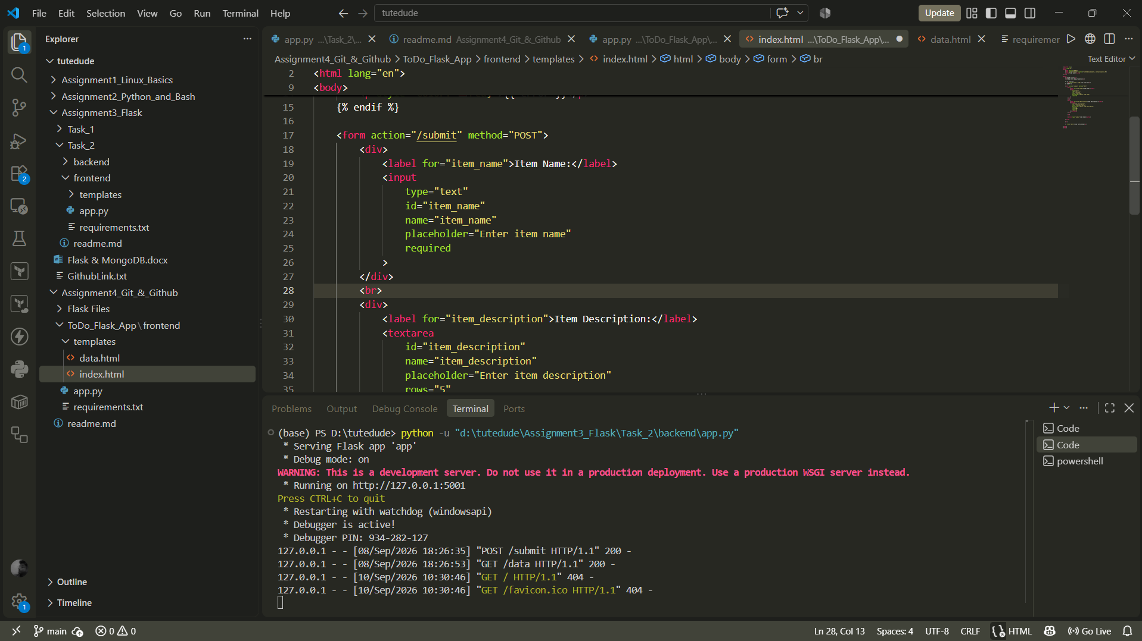

- Merge the _new branch into the main branch.
- If there are conflicts during the merge, resolve them by accepting the changes from the _new branch.
- Add the resolved changes to the staging area, commit them, and push the updates to the remote repository.

(base) PS D:\tutedude\Assignment4_Git_&_Github> git add .
(base) PS D:\tutedude\Assignment4_Git_&_Github> git status
On branch Lukky175_New
Changes to be committed:
(use "git restore --staged <file>..." to unstage)
modified: Task_2/frontend/templates/data.html

(base) PS D:\tutedude\Assignment4_Git_&_Github> git commit -m "Updated Some Changes"
[Lukky175_New 2696658] Updated Some Changes
1 file changed, 1 insertion(+)
(base) PS D:\tutedude\Assignment4_Git_&_Github> git push -u origin Lukky175_New
Enumerating objects: 11, done.
Counting objects: 100% (11/11), done.
Delta compression using up to 16 threads
Compressing objects: 100% (6/6), done.
Writing objects: 100% (6/6), 606 bytes | 202.00 KiB/s, done.
Total 6 (delta 2), reused 0 (delta 0), pack-reused 0 (from 0)
remote: Resolving deltas: 100% (2/2), completed with 2 local objects.
remote:
remote: Create a pull request for 'Lukky175_New' on GitHub by visiting:
remote: https://github.com/Lukky175/TuteDude_Git-GitHub/pull/new/Lukky175_New
remote:
To github.com:Lukky175/TuteDude_Git-GitHub.git
* [new branch] Lukky175_New -> Lukky175_New
branch 'Lukky175_New' set up to track 'origin/Lukky175_New'.
(base) PS D:\tutedude\Assignment4_Git_&_Github> git switch main
Switched to branch 'main'
(base) PS D:\tutedude\Assignment4_Git_&_Github> git branch -a
Lukky175
Lukky175_New
* main
remotes/origin/HEAD -> origin/main
remotes/origin/Lukky175
remotes/origin/Lukky175_New
remotes/origin/main
(base) PS D:\tutedude\Assignment4_Git_&_Github> git merge Lukky175_New
Updating 826e21b..2696658
Fast-forward
Task_2/frontend/templates/data.html | 1 +
1 file changed, 1 insertion(+)
(base) PS D:\tutedude\Assignment4_Git_&_Github> git status
On branch main
nothing to commit, working tree clean
(base) PS D:\tutedude\Assignment4_Git_&_Github> git add .
(base) PS D:\tutedude\Assignment4_Git_&_Github> git commit -m "Merged Branch"
On branch main
nothing to commit, working tree clean
(base) PS D:\tutedude\Assignment4_Git_&_Github> git push origin main
Total 0 (delta 0), reused 0 (delta 0), pack-reused 0 (from 0)
To github.com:Lukky175/TuteDude_Git-GitHub.git
826e21b..2696658 main -> main
(base) PS D:\tutedude\Assignment4_Git_&_Github>

Task 3: Parallel Feature Development
- Branch Creation: Create two branches, master_1 and master_2, from the main branch.
- Feature Development in master_1: Create a To-Do Page in the frontend with a form containing the fields Item Name and Item Description.
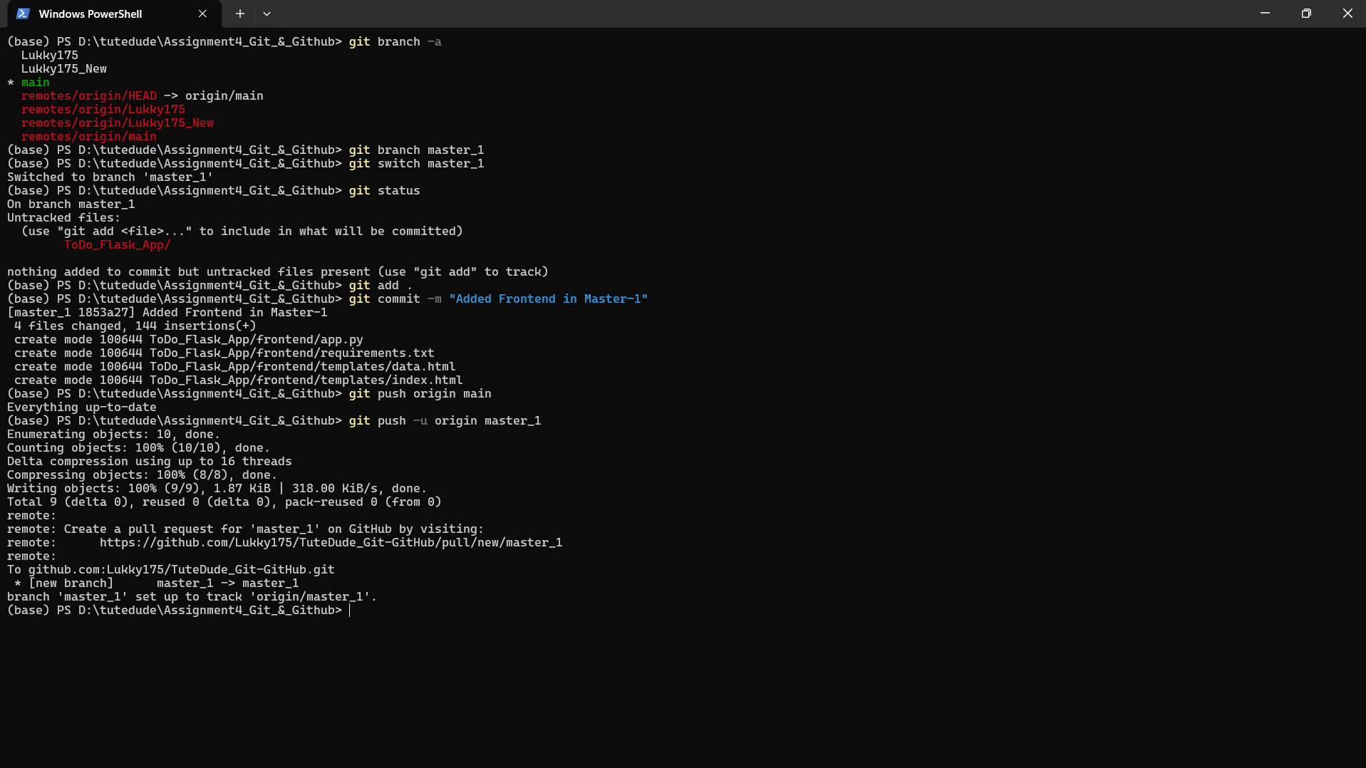

(base) PS D:\tutedude\Assignment4_Git_&_Github> git branch -a
Lukky175
Lukky175_New
* main
remotes/origin/HEAD -> origin/main
remotes/origin/Lukky175
remotes/origin/Lukky175_New
remotes/origin/main
(base) PS D:\tutedude\Assignment4_Git_&_Github> git branch master_1
(base) PS D:\tutedude\Assignment4_Git_&_Github> git switch master_1
Switched to branch 'master_1'
(base) PS D:\tutedude\Assignment4_Git_&_Github> git status
On branch master_1
Untracked files:
(use "git add <file>..." to include in what will be committed)
ToDo_Flask_App/

nothing added to commit but untracked files present (use "git add" to track)
(base) PS D:\tutedude\Assignment4_Git_&_Github> git add .
(base) PS D:\tutedude\Assignment4_Git_&_Github> git commit -m "Added Frontend in Master-1"
[master_1 1853a27] Added Frontend in Master-1
4 files changed, 144 insertions(+)
create mode 100644 ToDo_Flask_App/frontend/app.py
create mode 100644 ToDo_Flask_App/frontend/requirements.txt
create mode 100644 ToDo_Flask_App/frontend/templates/data.html
create mode 100644 ToDo_Flask_App/frontend/templates/index.html
(base) PS D:\tutedude\Assignment4_Git_&_Github> git push origin main
Everything up-to-date
(base) PS D:\tutedude\Assignment4_Git_&_Github> git push -u origin master_1
Enumerating objects: 10, done.
Counting objects: 100% (10/10), done.
Delta compression using up to 16 threads
Compressing objects: 100% (8/8), done.
Writing objects: 100% (9/9), 1.87 KiB | 318.00 KiB/s, done.
Total 9 (delta 0), reused 0 (delta 0), pack-reused 0 (from 0)
remote:
remote: Create a pull request for 'master_1' on GitHub by visiting:
remote: https://github.com/Lukky175/TuteDude_Git-GitHub/pull/new/master_1
remote:
To github.com:Lukky175/TuteDude_Git-GitHub.git
* [new branch] master_1 -> master_1
branch 'master_1' set up to track 'origin/master_1'.
(base) PS D:\tutedude\Assignment4_Git_&_Github>

- Backend API in master_2: Create a backend route named /submittodoitem that accepts itemName and itemDescription via a POST request and stores these details in a MongoDB database.
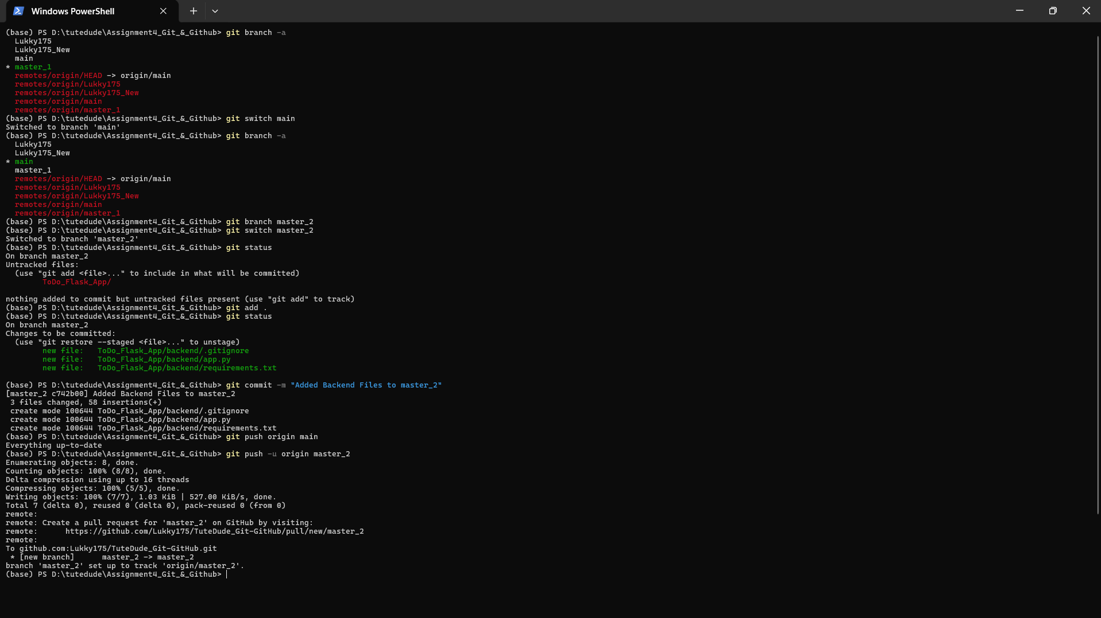
(base) PS D:\tutedude\Assignment4_Git_&_Github> git branch -a
Lukky175
Lukky175_New
main
* master_1
remotes/origin/HEAD -> origin/main
remotes/origin/Lukky175
remotes/origin/Lukky175_New
remotes/origin/main
remotes/origin/master_1
(base) PS D:\tutedude\Assignment4_Git_&_Github> git switch main
Switched to branch 'main'
(base) PS D:\tutedude\Assignment4_Git_&_Github> git branch -a
Lukky175
Lukky175_New
* main
master_1
remotes/origin/HEAD -> origin/main
remotes/origin/Lukky175
remotes/origin/Lukky175_New
remotes/origin/main
remotes/origin/master_1
(base) PS D:\tutedude\Assignment4_Git_&_Github> git branch master_2
(base) PS D:\tutedude\Assignment4_Git_&_Github> git switch master_2
Switched to branch 'master_2'
(base) PS D:\tutedude\Assignment4_Git_&_Github> git status
On branch master_2
Untracked files:
(use "git add <file>..." to include in what will be committed)
ToDo_Flask_App/

nothing added to commit but untracked files present (use "git add" to track)
(base) PS D:\tutedude\Assignment4_Git_&_Github> git add .
(base) PS D:\tutedude\Assignment4_Git_&_Github> git status
On branch master_2
Changes to be committed:
(use "git restore --staged <file>..." to unstage)
new file: ToDo_Flask_App/backend/.gitignore
new file: ToDo_Flask_App/backend/app.py
new file: ToDo_Flask_App/backend/requirements.txt

(base) PS D:\tutedude\Assignment4_Git_&_Github> git commit -m "Added Backend Files to master_2"
[master_2 c742b00] Added Backend Files to master_2
3 files changed, 58 insertions(+)
create mode 100644 ToDo_Flask_App/backend/.gitignore
create mode 100644 ToDo_Flask_App/backend/app.py
create mode 100644 ToDo_Flask_App/backend/requirements.txt
(base) PS D:\tutedude\Assignment4_Git_&_Github> git push origin main
Everything up-to-date
(base) PS D:\tutedude\Assignment4_Git_&_Github> git push -u origin master_2
Enumerating objects: 8, done.
Counting objects: 100% (8/8), done.
Delta compression using up to 16 threads
Compressing objects: 100% (5/5), done.
Writing objects: 100% (7/7), 1.03 KiB | 527.00 KiB/s, done.
Total 7 (delta 0), reused 0 (delta 0), pack-reused 0 (from 0)
remote:
remote: Create a pull request for 'master_2' on GitHub by visiting:
remote: https://github.com/Lukky175/TuteDude_Git-GitHub/pull/new/master_2
remote:
To github.com:Lukky175/TuteDude_Git-GitHub.git
* [new branch] master_2 -> master_2
branch 'master_2' set up to track 'origin/master_2'.
(base) PS D:\tutedude\Assignment4_Git_&_Github>

- Merging Changes: Merge the changes from both master_1 and master_2 into the main branch.
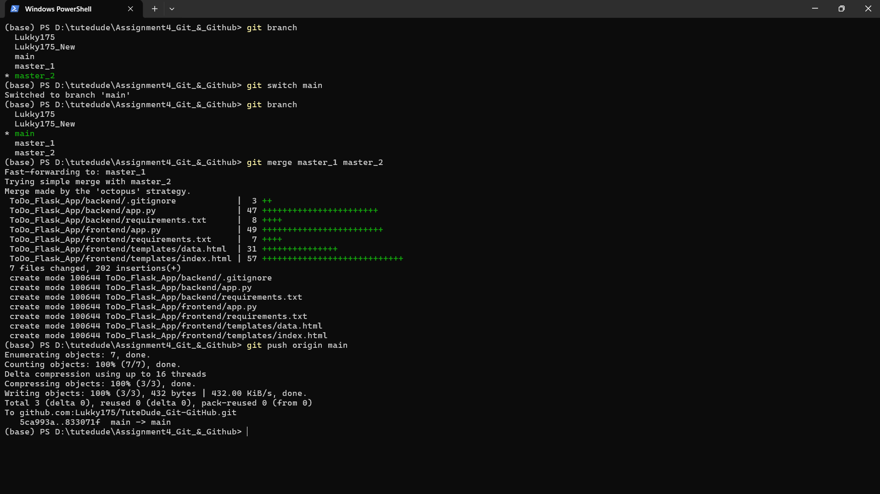

(base) PS D:\tutedude\Assignment4_Git_&_Github> git branch
Lukky175
Lukky175_New
main
master_1
* master_2
(base) PS D:\tutedude\Assignment4_Git_&_Github> git switch main
Switched to branch 'main'
(base) PS D:\tutedude\Assignment4_Git_&_Github> git branch
Lukky175
Lukky175_New
* main
master_1
master_2
(base) PS D:\tutedude\Assignment4_Git_&_Github> git merge master_1 master_2
Fast-forwarding to: master_1
Trying simple merge with master_2
Merge made by the 'octopus' strategy.
ToDo_Flask_App/backend/.gitignore | 3 ++
ToDo_Flask_App/backend/app.py | 47 +++++++++++++++++++++++
ToDo_Flask_App/backend/requirements.txt | 8 ++++
ToDo_Flask_App/frontend/app.py | 49 ++++++++++++++++++++++++
ToDo_Flask_App/frontend/requirements.txt | 7 ++++
ToDo_Flask_App/frontend/templates/data.html | 31 +++++++++++++++
ToDo_Flask_App/frontend/templates/index.html | 57 ++++++++++++++++++++++++++++
7 files changed, 202 insertions(+)
create mode 100644 ToDo_Flask_App/backend/.gitignore
create mode 100644 ToDo_Flask_App/backend/app.py
create mode 100644 ToDo_Flask_App/backend/requirements.txt
create mode 100644 ToDo_Flask_App/frontend/app.py
create mode 100644 ToDo_Flask_App/frontend/requirements.txt
create mode 100644 ToDo_Flask_App/frontend/templates/data.html
create mode 100644 ToDo_Flask_App/frontend/templates/index.html
(base) PS D:\tutedude\Assignment4_Git_&_Github> git push origin main
Enumerating objects: 7, done.
Counting objects: 100% (7/7), done.
Delta compression using up to 16 threads
Compressing objects: 100% (3/3), done.
Writing objects: 100% (3/3), 432 bytes | 432.00 KiB/s, done.
Total 3 (delta 0), reused 0 (delta 0), pack-reused 0 (from 0)
To github.com:Lukky175/TuteDude_Git-GitHub.git
5ca993a..833071f main -> main
(base) PS D:\tutedude\Assignment4_Git_&_Github>

Task 4: Sequential Commits, Reset & Rebase
- Enhancing the To-Do Form in master_1: Add the following fields to the To-Do form: Item ID, Item UUID, Item Hash.
- Committing in Sequence: Add and commit each field separately — first commit: Item ID; second commit: Item UUID; third commit: Item Hash.

(base) PS D:\tutedude\Assignment4_Git_&_Github> git branch
Lukky175
Lukky175_New
main
* master_1
master_2
(base) PS D:\tutedude\Assignment4_Git_&_Github> git status
On branch master_1
Your branch is ahead of 'origin/master_1' by 1 commit.
(use "git push" to publish your local commits)

Changes not staged for commit:
(use "git add <file>..." to update what will be committed)
(use "git restore <file>..." to discard changes in working directory)
modified: Flask Files/frontend/templates/index.html

no changes added to commit (use "git add" and/or "git commit -a")
(base) PS D:\tutedude\Assignment4_Git_&_Github> git add .
(base) PS D:\tutedude\Assignment4_Git_&_Github> git commit -m "Added Item ID Field"
[master_1 c1d3956] Added Item ID Field
1 file changed, 6 insertions(+)
(base) PS D:\tutedude\Assignment4_Git_&_Github> git add .
(base) PS D:\tutedude\Assignment4_Git_&_Github> git commit -m "Added Item UUID field"
[master_1 8d0a5c8] Added Item UUID field
1 file changed, 7 insertions(+)
(base) PS D:\tutedude\Assignment4_Git_&_Github> git add .
(base) PS D:\tutedude\Assignment4_Git_&_Github> git commit -m "Added Item Hash field"
[master_1 b2cbcaf] Added Item Hash field
1 file changed, 8 insertions(+), 1 deletion(-)
(base) PS D:\tutedude\Assignment4_Git_&_Github> git log --oneline -4
b2cbcaf (HEAD -> master_1) Added Item Hash field
8d0a5c8 Added Item UUID field
c1d3956 Added Item ID Field
93f4bd8 Files are now accurate

- Merging to main: Merge the master_1 branch into the main branch.

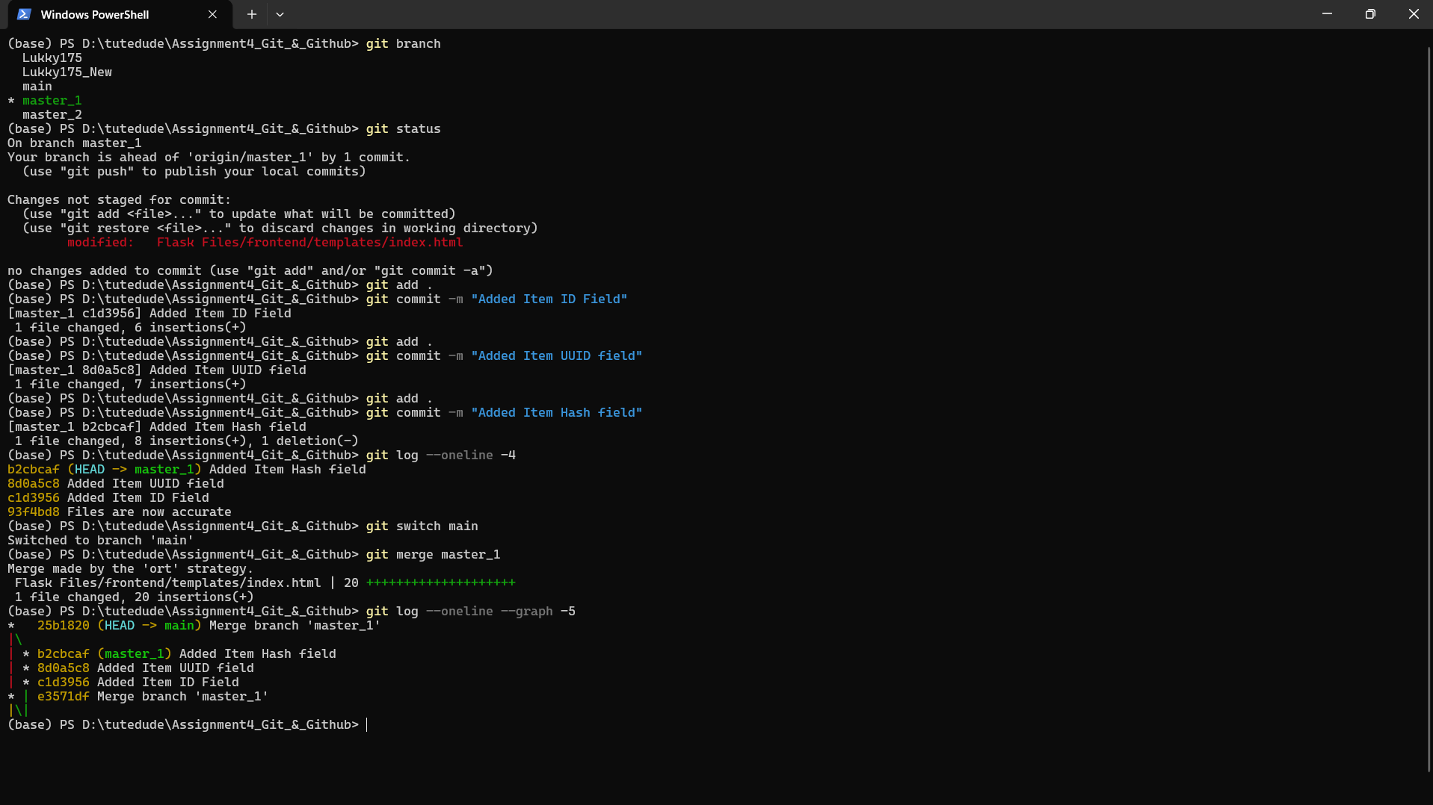

(base) PS D:\tutedude\Assignment4_Git_&_Github> git switch main
Switched to branch 'main'
(base) PS D:\tutedude\Assignment4_Git_&_Github> git merge master_1
Merge made by the 'ort' strategy.
Flask Files/frontend/templates/index.html | 20 ++++++++++++++++++++
1 file changed, 20 insertions(+)
(base) PS D:\tutedude\Assignment4_Git_&_Github> git log --oneline --graph -5
* 25b1820 (HEAD -> main) Merge branch 'master_1'
|\
| * b2cbcaf (master_1) Added Item Hash field
| * 8d0a5c8 Added Item UUID field
| * c1d3956 Added Item ID Field
* | e3571df Merge branch 'master_1'
|\|
(base) PS D:\tutedude\Assignment4_Git_&_Github>

- Git Reset: In the main branch, roll back to the commit where only the Item ID field was added. Use git reset --soft to ensure changes remain staged, then re-commit this state and merge it to main.
- Rebasing: Rebase the updated main branch changes onto master_1 using git rebase main master_1. Preserve individual commits (do NOT squash) to maintain commit history.
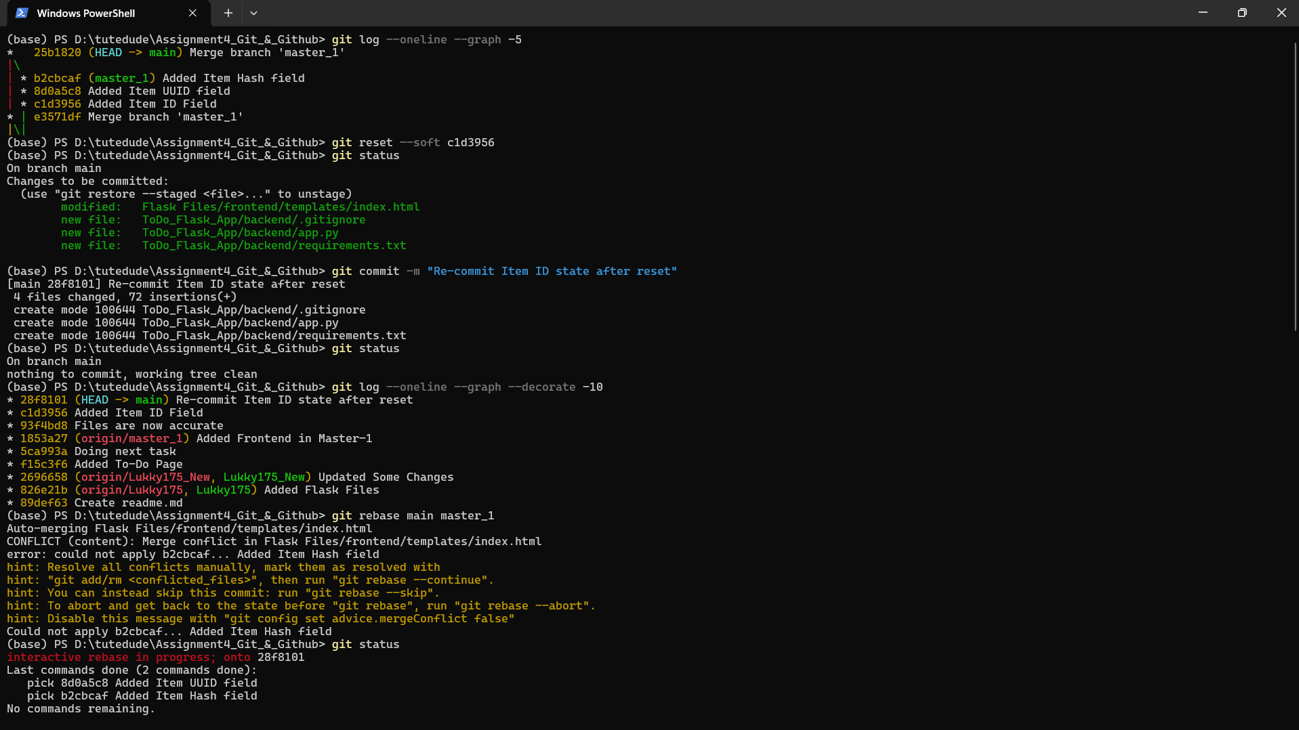
(base) PS D:\tutedude\Assignment4_Git_&_Github> git log --oneline --graph -5
* 25b1820 (HEAD -> main) Merge branch 'master_1'
|\
| * b2cbcaf (master_1) Added Item Hash field
| * 8d0a5c8 Added Item UUID field
| * c1d3956 Added Item ID Field
* | e3571df Merge branch 'master_1'
|\|
(base) PS D:\tutedude\Assignment4_Git_&_Github> git reset --soft c1d3956
(base) PS D:\tutedude\Assignment4_Git_&_Github> git status
On branch main
Changes to be committed:
(use "git restore --staged <file>..." to unstage)
modified: Flask Files/frontend/templates/index.html
new file: ToDo_Flask_App/backend/.gitignore
new file: ToDo_Flask_App/backend/app.py
new file: ToDo_Flask_App/backend/requirements.txt

(base) PS D:\tutedude\Assignment4_Git_&_Github> git commit -m "Re-commit Item ID state after reset"
[main 28f8101] Re-commit Item ID state after reset
4 files changed, 72 insertions(+)
create mode 100644 ToDo_Flask_App/backend/.gitignore
create mode 100644 ToDo_Flask_App/backend/app.py
create mode 100644 ToDo_Flask_App/backend/requirements.txt
(base) PS D:\tutedude\Assignment4_Git_&_Github> git status
On branch main
nothing to commit, working tree clean
(base) PS D:\tutedude\Assignment4_Git_&_Github> git log --oneline --graph --decorate -10
* 28f8101 (HEAD -> main) Re-commit Item ID state after reset
* c1d3956 Added Item ID Field
* 93f4bd8 Files are now accurate
* 1853a27 (origin/master_1) Added Frontend in Master-1
* 5ca993a Doing next task
* f15c3f6 Added To-Do Page
* 2696658 (origin/Lukky175_New, Lukky175_New) Updated Some Changes
* 826e21b (origin/Lukky175, Lukky175) Added Flask Files
* 89def63 Create readme.md
(base) PS D:\tutedude\Assignment4_Git_&_Github> git rebase main master_1
Auto-merging Flask Files/frontend/templates/index.html
CONFLICT (content): Merge conflict in Flask Files/frontend/templates/index.html
error: could not apply b2cbcaf... Added Item Hash field
hint: Resolve all conflicts manually, mark them as resolved with
hint: "git add/rm <conflicted_files>", then run "git rebase --continue".
hint: You can instead skip this commit: run "git rebase --skip".
hint: To abort and get back to the state before "git rebase", run "git rebase --abort".
hint: Disable this message with "git config set advice.mergeConflict false"
Could not apply b2cbcaf... Added Item Hash field
(base) PS D:\tutedude\Assignment4_Git_&_Github> git status
interactive rebase in progress; onto 28f8101
Last commands done (2 commands done):
pick 8d0a5c8 Added Item UUID field
pick b2cbcaf Added Item Hash field
No commands remaining.
You are currently rebasing branch 'master_1' on '28f8101'.
(fix conflicts and then run "git rebase --continue")
(use "git rebase --skip" to skip this patch)
(use "git rebase --abort" to check out the original branch)

Unmerged paths:
(use "git restore --staged <file>..." to unstage)
(use "git add <file>..." to mark resolution)
both modified: Flask Files/frontend/templates/index.html

no changes added to commit (use "git add" and/or "git commit -a")
(base) PS D:\tutedude\Assignment4_Git_&_Github> git diff
diff --cc Flask Files/frontend/templates/index.html
index 2399903,8d3b902..0000000
--- a/Flask Files/frontend/templates/index.html
+++ b/Flask Files/frontend/templates/index.html
@@@ -45,13 -45,6 +45,16 @@@
<br>

<div>
++<<<<<<< HEAD
+ <label for="itemUUID">Item UUID:</label>
+ <input type="text" id="itemUUID" name="itemUUID" required>
+ </div>
+
+ <br>
+
+ <div>
++=======
++>>>>>>> b2cbcaf (Added Item Hash field)
<label for="itemHash">Item Hash:</label>
<input type="text" id="itemHash" name="itemHash" required>
</div>
(base) PS D:\tutedude\Assignment4_Git_&_Github> git add "Flask Files/frontend/templates/index.html"
(base) PS D:\tutedude\Assignment4_Git_&_Github> git status
interactive rebase in progress; onto 28f8101
Last commands done (2 commands done):
pick 8d0a5c8 Added Item UUID field
pick b2cbcaf Added Item Hash field
No commands remaining.
You are currently rebasing branch 'master_1' on '28f8101'.
(all conflicts fixed: run "git rebase --continue")

Changes to be committed:
(use "git restore --staged <file>..." to unstage)
modified: Flask Files/frontend/templates/index.html

(base) PS D:\tutedude\Assignment4_Git_&_Github> git rebase --continue
[detached HEAD 48e927b] Added Item Hash field
1 file changed, 2 insertions(+), 2 deletions(-)
Successfully rebased and updated refs/heads/master_1.
(base) PS D:\tutedude\Assignment4_Git_&_Github> git status
On branch master_1
Your branch is ahead of 'origin/master_1' by 5 commits.
(use "git push" to publish your local commits)

nothing to commit, working tree clean
(base) PS D:\tutedude\Assignment4_Git_&_Github> git log --oneline --graph --decorate -10
* 48e927b (HEAD -> master_1) Added Item Hash field
* defaeb4 Added Item UUID field
* 28f8101 (main) Re-commit Item ID state after reset
* c1d3956 Added Item ID Field
* 93f4bd8 Files are now accurate
* 1853a27 (origin/master_1) Added Frontend in Master-1
* 5ca993a Doing next task
* f15c3f6 Added To-Do Page
* 2696658 (origin/Lukky175_New, Lukky175_New) Updated Some Changes
* 826e21b (origin/Lukky175, Lukky175) Added Flask Files
(base) PS D:\tutedude\Assignment4_Git_&_Github>

All Tasks have been Performed and Verified, With Codes and Screenshots mentioned, Source code is in the Zip file

Github repo for this assessment https://github.com/Lukky175/TuteDude_Git-GitHub.git
Github repo for all assessments: https://github.com/Lukky175/tute_dude_assignments.git

